FIDS 2.0 USER MANUAL

July 2012

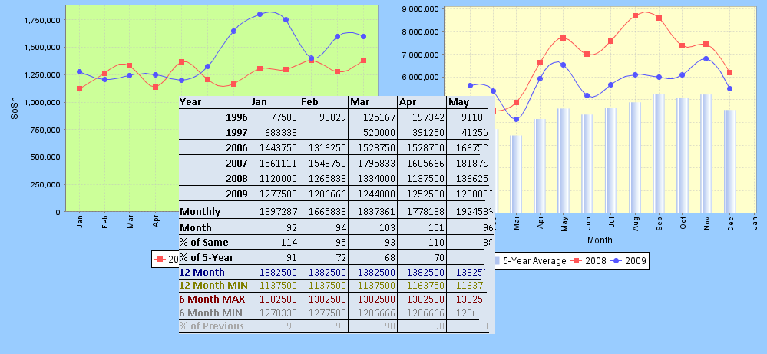

FSNAU

July 2012

©All Rights Reserved

Table of Contents

System requirements 2

Installing FIDS 2.0 2

Configuring FIDS 2.0 2

Starting and closing FIDS 2.0 4

Data Entry 6

Entering data 6

Markets data 6

SLIMS part 1 6

SLIMS Part 2 7

Saving data 8

Sending data by E-mail 8

Sending data by SMS(Short Messaging Service) 9

Viewing saved data 9

Data Cleaning 9

Fetching stored data for viewing 10

Editing/cleaning stored markets data 10

Editing/cleaning stored SLIMS part 1 data 11

Editing/cleaning stored SLIMS part 2 data 11

Clearing data 11

Data Analysis and Reports 12

Performing monthly analysis 12

Markets data analysis 12

SLIMS data analysis 13

Performing TOT(Terms of Trade) analysis 13

# System requirements

FIDS 2.0 requires an environment with a set of requirements to run.

These are the minimum system requirements;

1. 512 MB RAM or higher
2. 100 MB free hard disk space
3. 1.0 GHz processor speed

Required Software

1. Java JRE 1.7 or higher
2. MySQL 5.1 or later.

# Installing FIDS 2.0

FIDS 2.0 is deployed as a Java jar file. This makes it platform independent and therefore can be deployed on any computer system which has Java installed regardless of operating system.

To install the application;

1. Copy the **Fids** folder to C:\ directory of your computer. This folder contains all the files required for the application to run successfully.
2. Create a shortcut of **Fids.jar** file which is found inside the **Fids** folder. To create a shortcut, right click the file **Fids.jar** in the application folder. From the resulting pop-up menu, click on **Create Shortcut.**
3. Copy shortcut created in (b) above and paste on the desktop.
4. To add the application to the start menu, drag the shortcut on the desktop and drop it on the start button.

# Starting and closing FIDS 2.0

The application can be accessed from the start men or the desktop as a shortcut icon.

To start the application from the start menu;

1. Click on the start button
2. From the resulting menu click on **FIDS** shortcut. Notice the red rectangle on Figure 1 below.

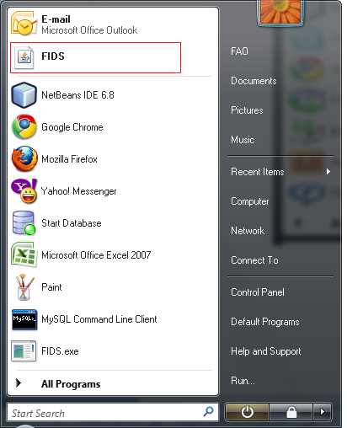

Figure 1 : Fids icon on start menu

1. Wait for the application to start. On start, the following window will appear, Figure 2 below.

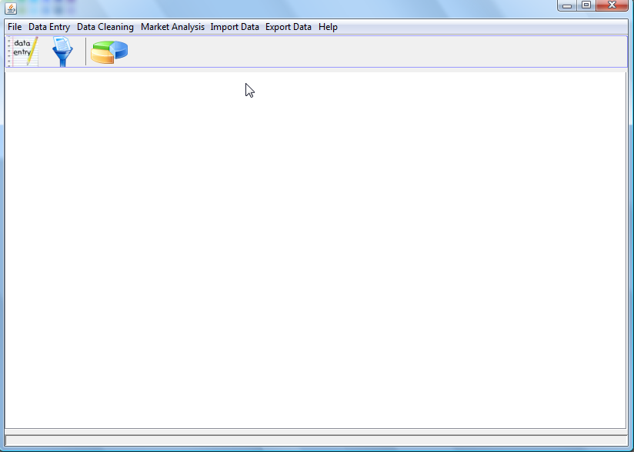

Figure 2 : Fids main window

To start the application from the desktop icon, locate the icon on the desktop then double click on it. Wait for the application to start. On start, the above window (Figure 2) will show up.

To close the application, click on the window close button on the top right corner of window (Figure 2)

# Data Entry

This module is used to enter data in to the system. There are three tabs in this module,

* Markets data
* SLIMS part 1
* SLIMS part 2.

The data entry module is launched from the main menu. To launch it, click on the **Data Entry** menu and click on one of the menu items Markets, Slims Part1 or Slims Part 2. The following window shows up, Figure 3.

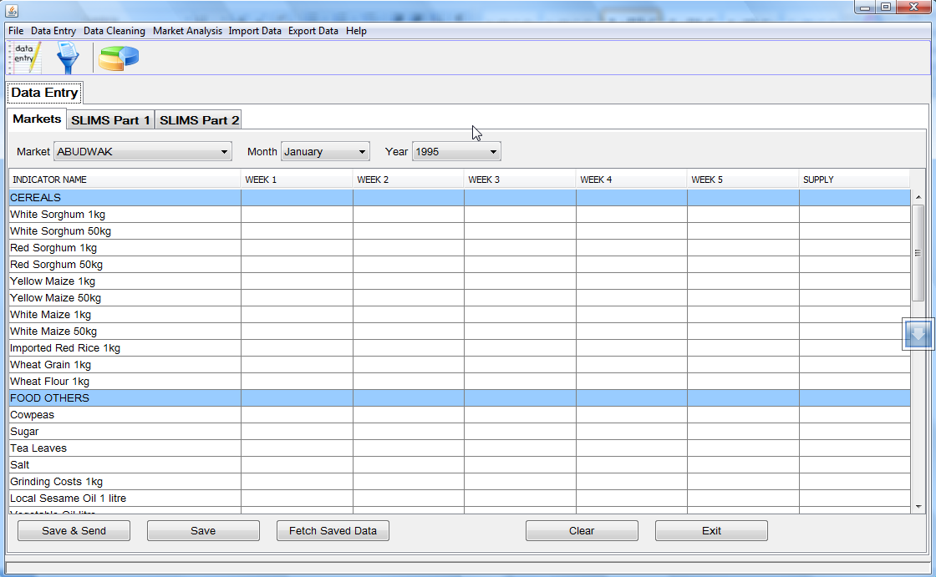

Figure 3 : Fids Data Entry

The window above (Figure 3) is the **Markets** data entry tab. This tab will be used for data entry of markets data. Use Slims Part 1 tab for Slims Part 1 data entry and Slims Part 2 tab for Slims Part 2 data entry.

## Entering data

### Markets data

1. To enter markets data, use the markets tab.
2. Choose the market e.g ABUDWAK, month e.g July and year e.g 2012.
3. Start entering data by typing prices on the table, as shown on Figure 4 below
4. For months that have 5 weeks, enter data in all the weeks 1 through 5. For 4 week months, enter data for four weeks.
5. Select **Supply** level from the last columns drop down list. Each row that has data has to have **Supply** level selected. Failure to select Supply level will result in validation error when saving data, see Figure below

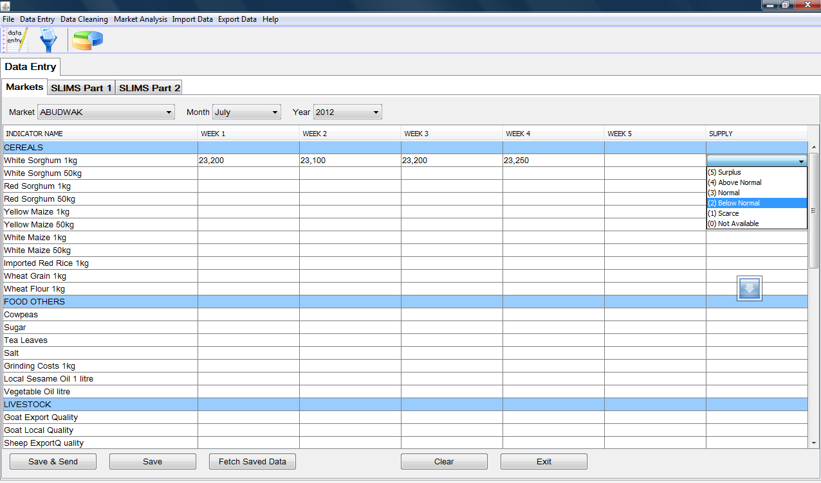

Figure 4 : Fids Markets Data Entry

### SLIMS part 1

1. To enter Slims Part 1 data, use the Slims Part 1 tab.
2. Choose the node e.g ADAADLEY, month e.g July and year e.g 2012.
3. Start entering data by typing prices on the table, as shown on Figure 5 below
4. For months that have 5 weeks, enter data in all the weeks 1 through 5. For 4 week months, enter data for four weeks.
5. At the end of each category, enter Location Name, Key Informant, Triangulation and Data Trust Level
6. Enter comments that you may have regarding the data entered in the comments section at the lower end of the table.

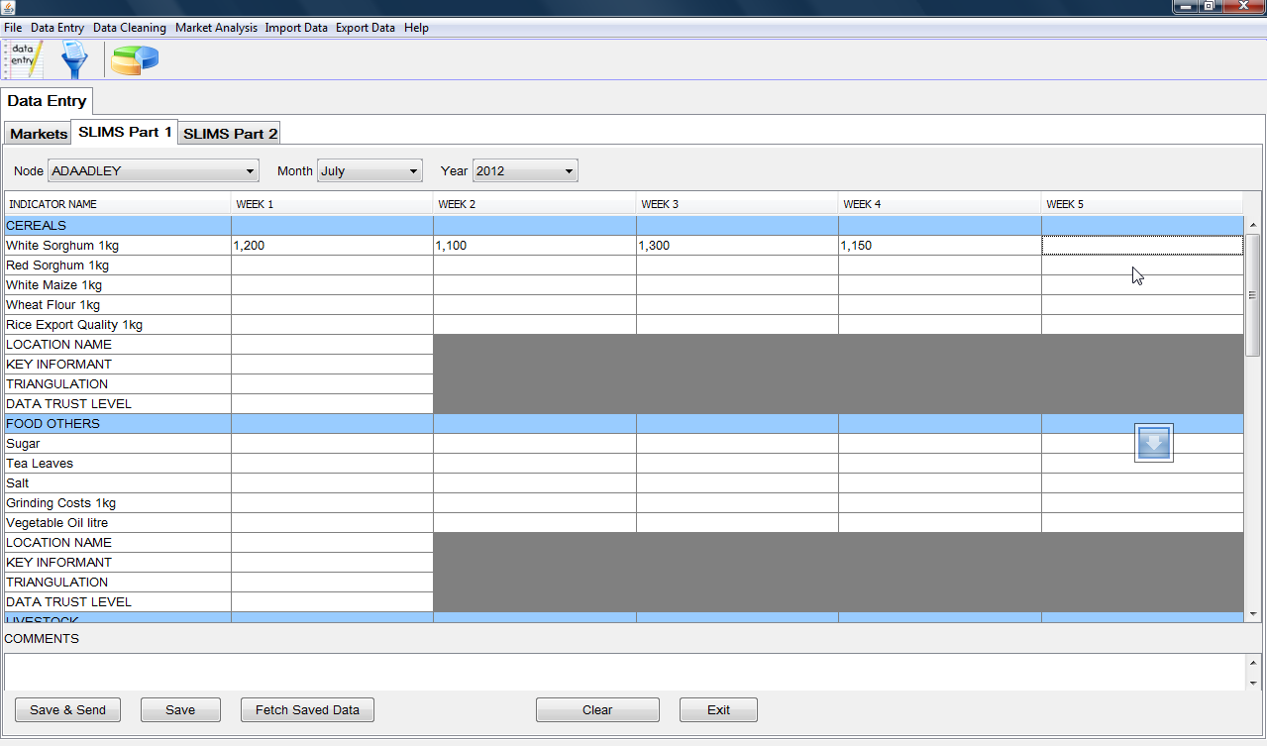

Figure 5 : Fids Slims Part 1 Data Entry

### SLIMS Part 2

Unlike in Markets and SLIMS part 1, in SLIMS part 2, data is entered in month basis. That is, there is one data record for an indicator per month. The data is not based on weeks as is the case with Markets and Slims Part 1.

1. To enter Slims Part 2 data, use the Slims Part 2 tab.
2. Choose the node e.g ADAADLEY, month e.g July and year e.g 2012 as shown on Figure 6 below.
3. Enter month value, location name, key informant, triangulation and data trust level for each indicator.
4. Enter comments that you may have regarding the data entered in the comments section at the lower end of the table.

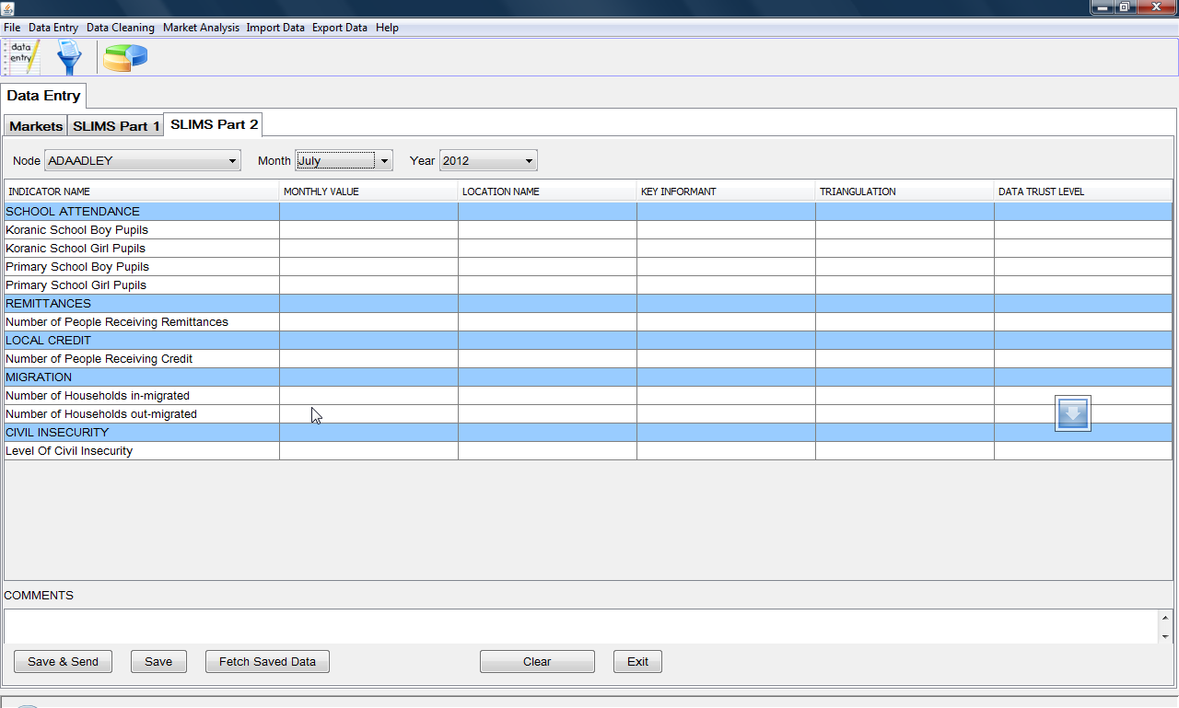

Figure 6 : Fids Slims Part 2 Data Entry

## Saving data

After data has been typed in any of the data entry forms, the next step is to save the data for future use. To achieve this, there are two options available.

First, a user can save data by clicking on the **Save**.

When the **Save** button is used to save data, data is saved locally on the computer. Us the Save button when saving data that does not need to be sent or if you intend to send the data later, for example where you are entering data and don’t have Internet connection.

Secondly, to save data, a user can click on the **Save & Send** button. In this approach, the data is first saved in the local computer then sent to server for processing, cleaning and storage. Use the **Save & Send** button when saving and sending data, use it only when you are connected to the Internet.

Both of these buttons Save and Save & Send are available on all the three data entry tabs, namely; Markets, Slims Part 1 and Slims Part 2

## Sending Data

There are two ways in which saved data can be sent. These are;

1. By clicking on **Save & Send** button.

Using the above button, data is saved and sent automatically. To use this method, ensure you are connected to the Internet first.

1. Attaching data files to email and sending.

This method involves going back to data files created after data has been saved and attaching the files in email and sending. This method is recommended where there is no Internet connection when entering data or where you are resending data that had been saved before. Whenever the **Save** data button is used to save data, this method should be used to send the data. The data files are found on the C:\FidsData folder. For example, data for Abudwak Market, year 2012 July will be found in file

**C:\FidsData\Markets\2012\ ABUDWAK2012July.xml**

The user then selects **Email** checkbox as shown in the graphic above

Next, user should click on **Send** button to send data by email.

NOTE: User needs to be connected to the internet to be able to send data by email.

## Viewing saved data

After data has been saved or saved and send, a user may have a need to view the data. To achieve this, the following is the procedure.

* Choose the required filters (year, month, market/node name).
* Click on **Fetch Saved Data.**

# Data Cleaning

This module enables users to make changes to already saved data. It is the only avenue to editing data that is already stored.

To use the data cleaning module, users need to be on the main window then select **Data Cleaning** menu item, and then click on **Clean Data** Sub menu item.

Data cleaning is done per dataset, which is markets, SLIMS Part 1 and SLIMS Part 2. The graphic below shows the data cleaning window.

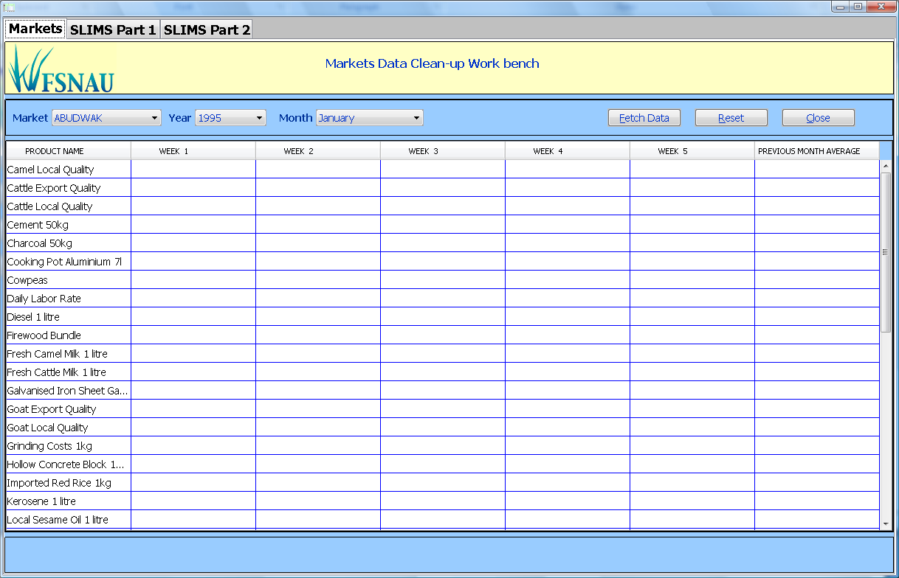

## Fetching stored data for viewing

To view data that is already stored in the database, a user has to select market/node name, year name and month name. Next user needs to click on **Fetch Data** button.

Wait till the data is completely loaded, this will be signalled by cursor changing from a busy (hour glass) to the default cursor.

In a case where data for chosen market/node, month and year does not exist in the database, the following error message will be displayed.

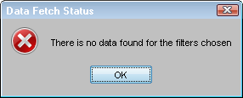

## Editing/cleaning stored markets data

1. Making changes to markets data, user needs to select the **Markets** tab on the Data cleaning window shown above.
2. Next, choose the market name, month name, and year name of the data you need to clean. Then click on **Fetch Data** button.
3. Wait till the data is completely fetched and populated on the cells.
4. The previous month column will hold average commodity price of month before the currently chosen month. The columns week1 through to week5 will hold commodity prices in each of the corresponding weeks.
5. Once the data is completely loaded, user can start editing data by replacing the values in cells for column week1 through to week5. Note that the commodity names and the values in **Previous Month Average** column cannot be edited. Once user has edited a value, the value will be automatically changed without having to do any further thing.
6. Please note that, sometimes the changes may take a few seconds to happen after a user has edited a value. As such, a few seconds of non response from the application may be noticed. In this case, exercise a little patience.

## Editing/cleaning stored SLIMS part 1 data

Same case as markets, only difference is that the SLIMS Part 1 tab is used as opposed to the markets tab.

## Editing/cleaning stored SLIMS part 2 data

Editing is done in SLIMS Part 2 tab

Same procedure as markets except that here, data is monthly and not weekly like in markets. Changes will be made to the data in cells of **Monthly Value** column

## Clearing data

To clear previously fetched data, click on **Reset** button on any of the three tabs.

# Data Analysis and Reports

Reports module is helps in data analysis and reporting. To open, in the main window, user needs to select **Analysis** menu item then click on **Generate Reports & Charts** sub menu item. Outputs that can be generated in this module are tables and chart/graphs. There are various ways of creating a table and graph with data. This depends on whether user is performing monthly analysis or TOT analysis.

Each of these is explained below. Below is a snapshot of the reports window.

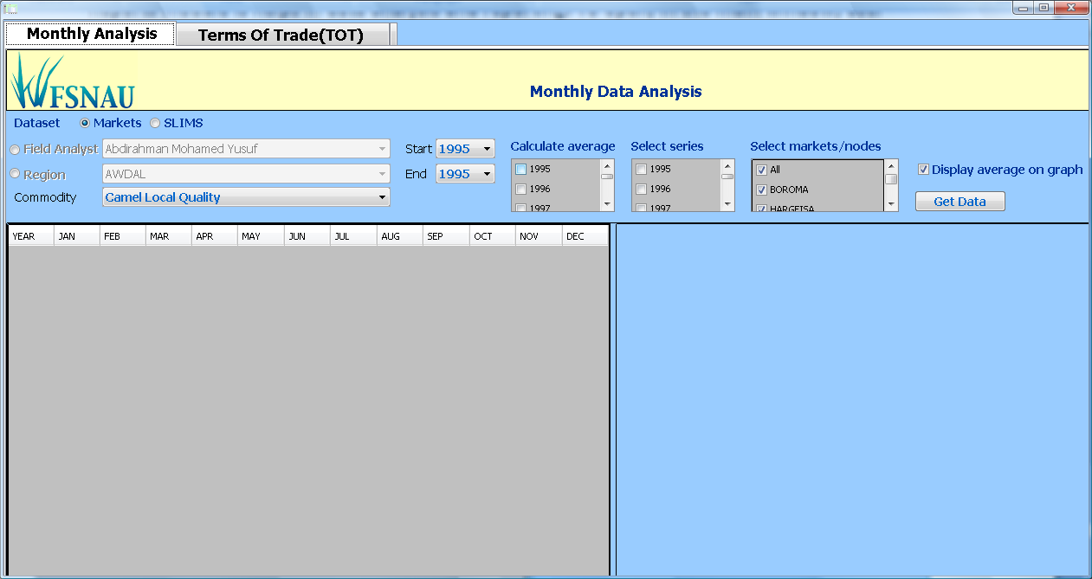

## Performing monthly analysis

### Markets data analysis

* + - * To perform markets data analysis, do the following
      * Select the Markets radio button
      * Select either a field analyst or region
* To select a field analyst, select the **Field Analyst** radio button. This will enable the Field Analyst combo box. Select the Field Analyst from the combo box.
* To select a region, select the **Region** radio button. This will enable the Region combo box. Select the Region from the combo box.
* Choose commodity by selecting one from the commodities combo box.
* Choose the **Start** and **End** years.
* Select at most 5 years to use for calculation of 5-year average. You can skip if you don’t want to calculate five year average.
* Select series years to be plotted on the graph.
* Select one or more markets, you could click the **All** check box to select all the markets in the current region or for the chosen Field analyst.
* Finally, click **Get Data** button to populate the table with data and draw graph.

The snapshot below shows a table and chart

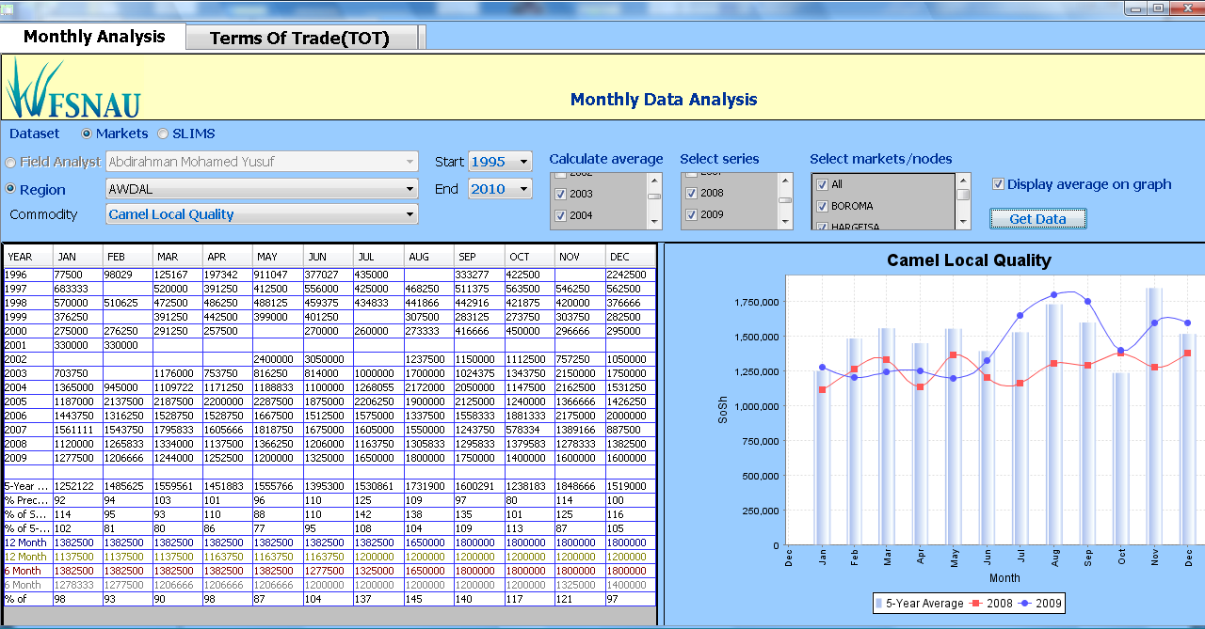

### SLIMS data analysis

To perform, SLIMs data analysis, select the SLIMs radio button

Follow the same procedure used for markets above.

## Performing TOT (Terms of Trade) analysis

* This helps to compare terms of trade between two commodities. This is how to perform a TOT.
* Select the TOT (Terms of Trade) tab
* Select region or field analyst (explained under markets above)
* Choose Start and End years
* Select First Commodity and Second commodity
* Choose at most five years for 5-year average calculation
* Select series years for plotting on the graph; choose at most 5 and at least 1
* Select at least one market. By default, all markets are selected; clicking **All** checkbox will select all markets in current region or under the chosen Field analyst
* Finally, click on **Get Data** button to populate the table with data and draw graph.

The snapshot below shows a TOT graph and table

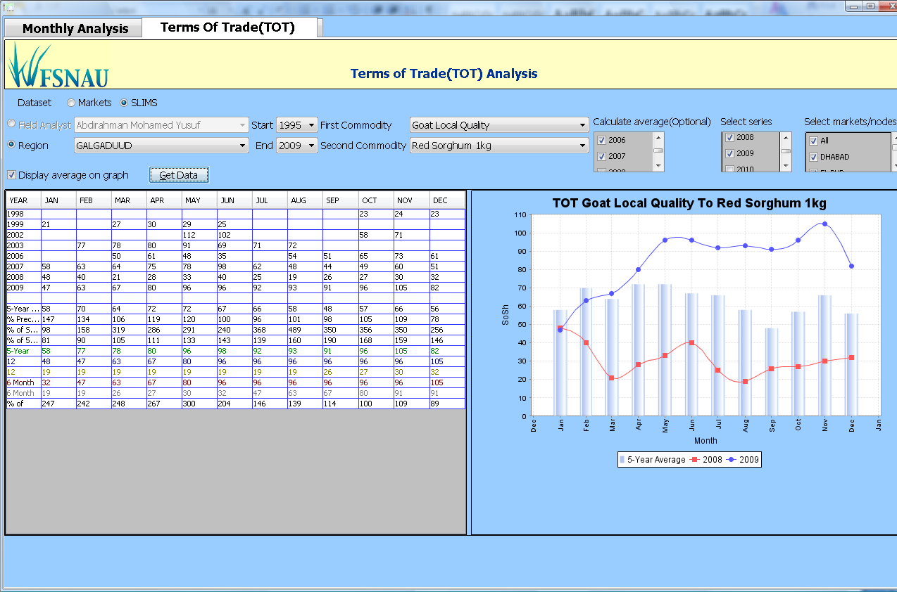

## Data Import

Data send by Email will have to be imported to the database. This module performs the task of extracting data from the XML file sent as an Email attachment. The data is then saved in the database; as such there is no difference between data send by Email and that sent by SMS, the only difference being the means of sending. The Data Import window is shown below.

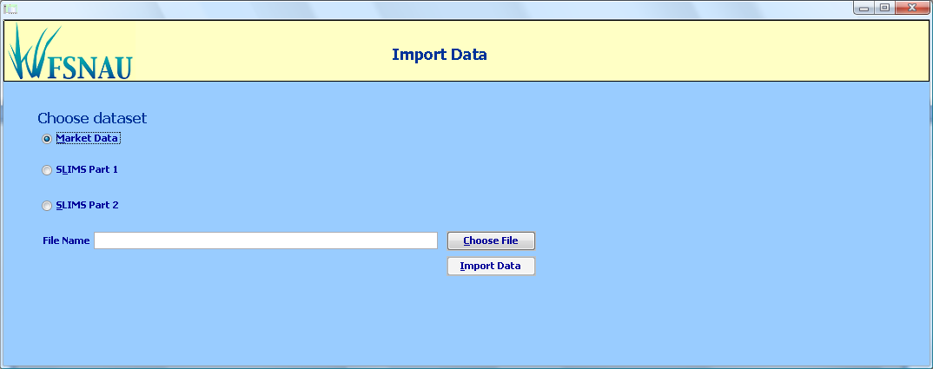

To use this module, a user needs follow the following procedure;

## Importing Markets data

1. Select **Market Data** check box.
2. Click on **Choose File** button to select the XML file to import data from
3. **Import Data** button will be enabled after a file has been chosen
4. Click on **Import Data** button**.**
5. The following dialog will pop up to show data importation succeeded

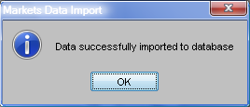

## Importing SLIMS Part 1 data

1. Select **SLIMS Part 1** check box.
2. Click on **Choose File** button to select the XML file to import data from
3. **Import Data** button will be enabled after a file has been chosen
4. Click on **Import Data** button**.**
5. Thedialog above will pop up to show data importation succeeded

## Importing SLIMS Part 2 data

1. Select **SLIMS Part 2** check box.
2. Click on **Choose File** button to select the XML file to import data from
3. **Import Data** button will be enabled after a file has been chosen
4. Click on **Import Data** button**.**
5. Thedialog above will pop up to show data importation succeeded